REVISION FOR UNITS 3-4 (Tuần 16 – Anh 9)
Grammar notes:

- ADVERB CLAUSES OF RESULT (Mệnh đề trạng ngữ chỉ kết quả)

So + result (So – kết quả/ hậu quả)
So (vì thế; vì vậy; cho nên) là một liên từ (conjunction) được dùng để diễn đạt kết quà của một sự việc hoặc một hành động. Mệnh đề bắt đầu bằng So được gọi là mệnh đề trạng ngữ chỉ kết quả (Adverb clauses of result).
Eg:
- We arrived late, so we missed the beginning of the film. (Chúng tôi đến trễ, vì thế chúng tôi bỏ lỡ phần đầu của bộ phim.)
- It was cold, so I turned the heating on. (Trời lạnh, vì vậy tôi đã mở hệ thống sưởi.)
- The computer didn't work, so he took it back to the shop. (Máy vi tính không hoạt động, vì vậy anh ấy đã mang nó trở lại cửa hàng.)
Hãy so sánh với:
Because + reason (bởi vì + nguyên nhân)
Eg:
- We missed the beginning of the film because we arrived late. (Chúng tôi đã bỏ lỡ phần đầu của bộ phim bởi vì chúng tôi đến trễ.)
→We arrived late, so we missed the beginning of the film.
- The flight was delayed because there was fog. (Chuyến bay bị hoãn lại bởi vì có sương mù.)
→There was fog, so the flight was delayed.
- S + V + so + adj/ adv. + that Clause
Eg: Ba is very lazy, so he can’t pass the xam. → Ba is so lazy that he can’t pass the exam.
Exercises: Rewrite the sentences, using “so”
1. I can’t go out with you because I’m very busy. → I _________________________________
2. We didn’t go camping because it rained heavily. → It ________________________________
3. Tom doesn’t like Mary because she’s very talkative. → Mary _________________________
4. The boy couldn’t do the exercise because it was very difficult. → The exercise ___________ _____________________________________________________________________
5. Hoa can’t try on the shoes because they are very small. → The shoes ____________________ ___________________________________

II. PREPOSITIONS OF TIME: ON – IN – AT
1. ON: Ta thường dùng “on” cho ngày, thứ
Eg: We have Math on Wednesday and Friday.
Did you say you were born on December 24th?
Hoặc: What do you often do on New Year’s Eve?
2. IN: Ta thường dùng “in” cho năm, tháng, mùa, buổi:
Eg: He bought this house in 2017.
Hoa first met Lam in August.
Are you busy in the afternoon?
It’s very hot in the summer.
3. AT: Ta dùng “at” để chỉ giờ
Eg: Our classes start at 7 am.
Lưu ý: Chỉ sử dụng in – on – at trong các câu có thì đơn, không dùng cho Present Perfect hay Present/ Past Continuous
Exercise:
1. The man goes to work __________________ the morning.
2. OK. Let’s meet ______________ 6.30 outside the theater.
3. We have a day off ________________ January 1st every year.
4. Would you like to go to the movie with me _______________ Sunday?
5. The weather is very cold ______________ the winter.
III. REPORTED SPEECH
- Commands – Requests - Advice (Mệnh lệnh – Yêu cầu – Lời khuyên)
S + asked / told / advised sb (not) to do sth.
Eg 1: “Please open the door, Hoa.” – Mr. Ba said.
→Mr. Ba asked Hoa to open the door.
Eg 2: “You shouldn’t smoke, Mr. Long.” – said the doctor.
→ The doctor advised Mr. Long not to smoke.
- Statements (Câu kể/ Câu trần thuật)
S + said + S + Ved…
told + O + S + Ved….
- Minh said: “ I’m a student.” → Minh said he was a student.
- Minh said: “I like your new hair style, Linh.” → Minh told Linh (that) he liked her new hair style.
- Questions
- Yes – No questions
S + asked + O + if / whether S +V-ed/ 2….
Eg 1: “Are you tired today, Ngoc?” - said the teacher.
→The teacher asked Ngoc if / whether she was tired that day.
Eg 2: “Do you like this song, children?” – said Miss Lien.
→Miss Lien asked the children if they liked that song.
Eg 3: “Can you swim?” he said to me.
→He asked me if I could swim.
- Wh- questions
S + asked + O + what/ when /where… + S + Ved/2….
Eg 1: “Where are you going now, Thanh?” – they said.
→ They asked Thanh where she was going then.
Eg 2: “How much do I have to pay?” – she said to the salesman.
→ She asked the salesman how much she had to pay.
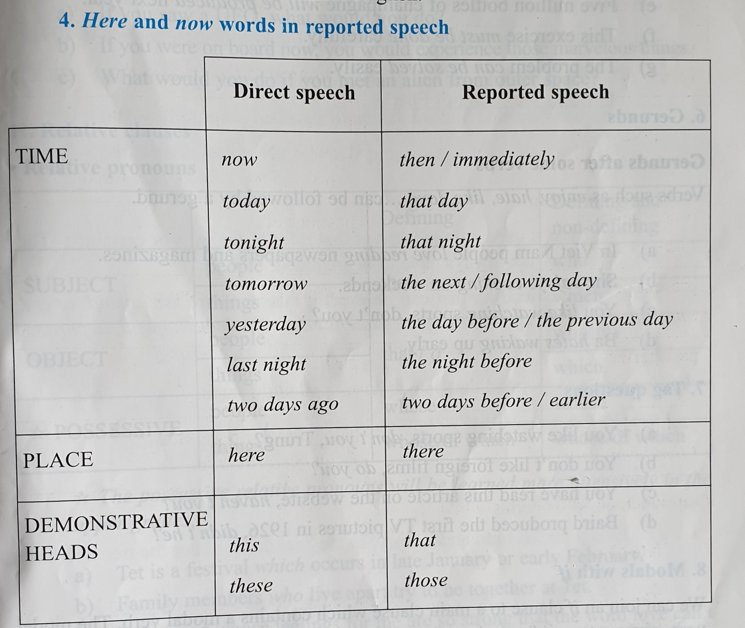

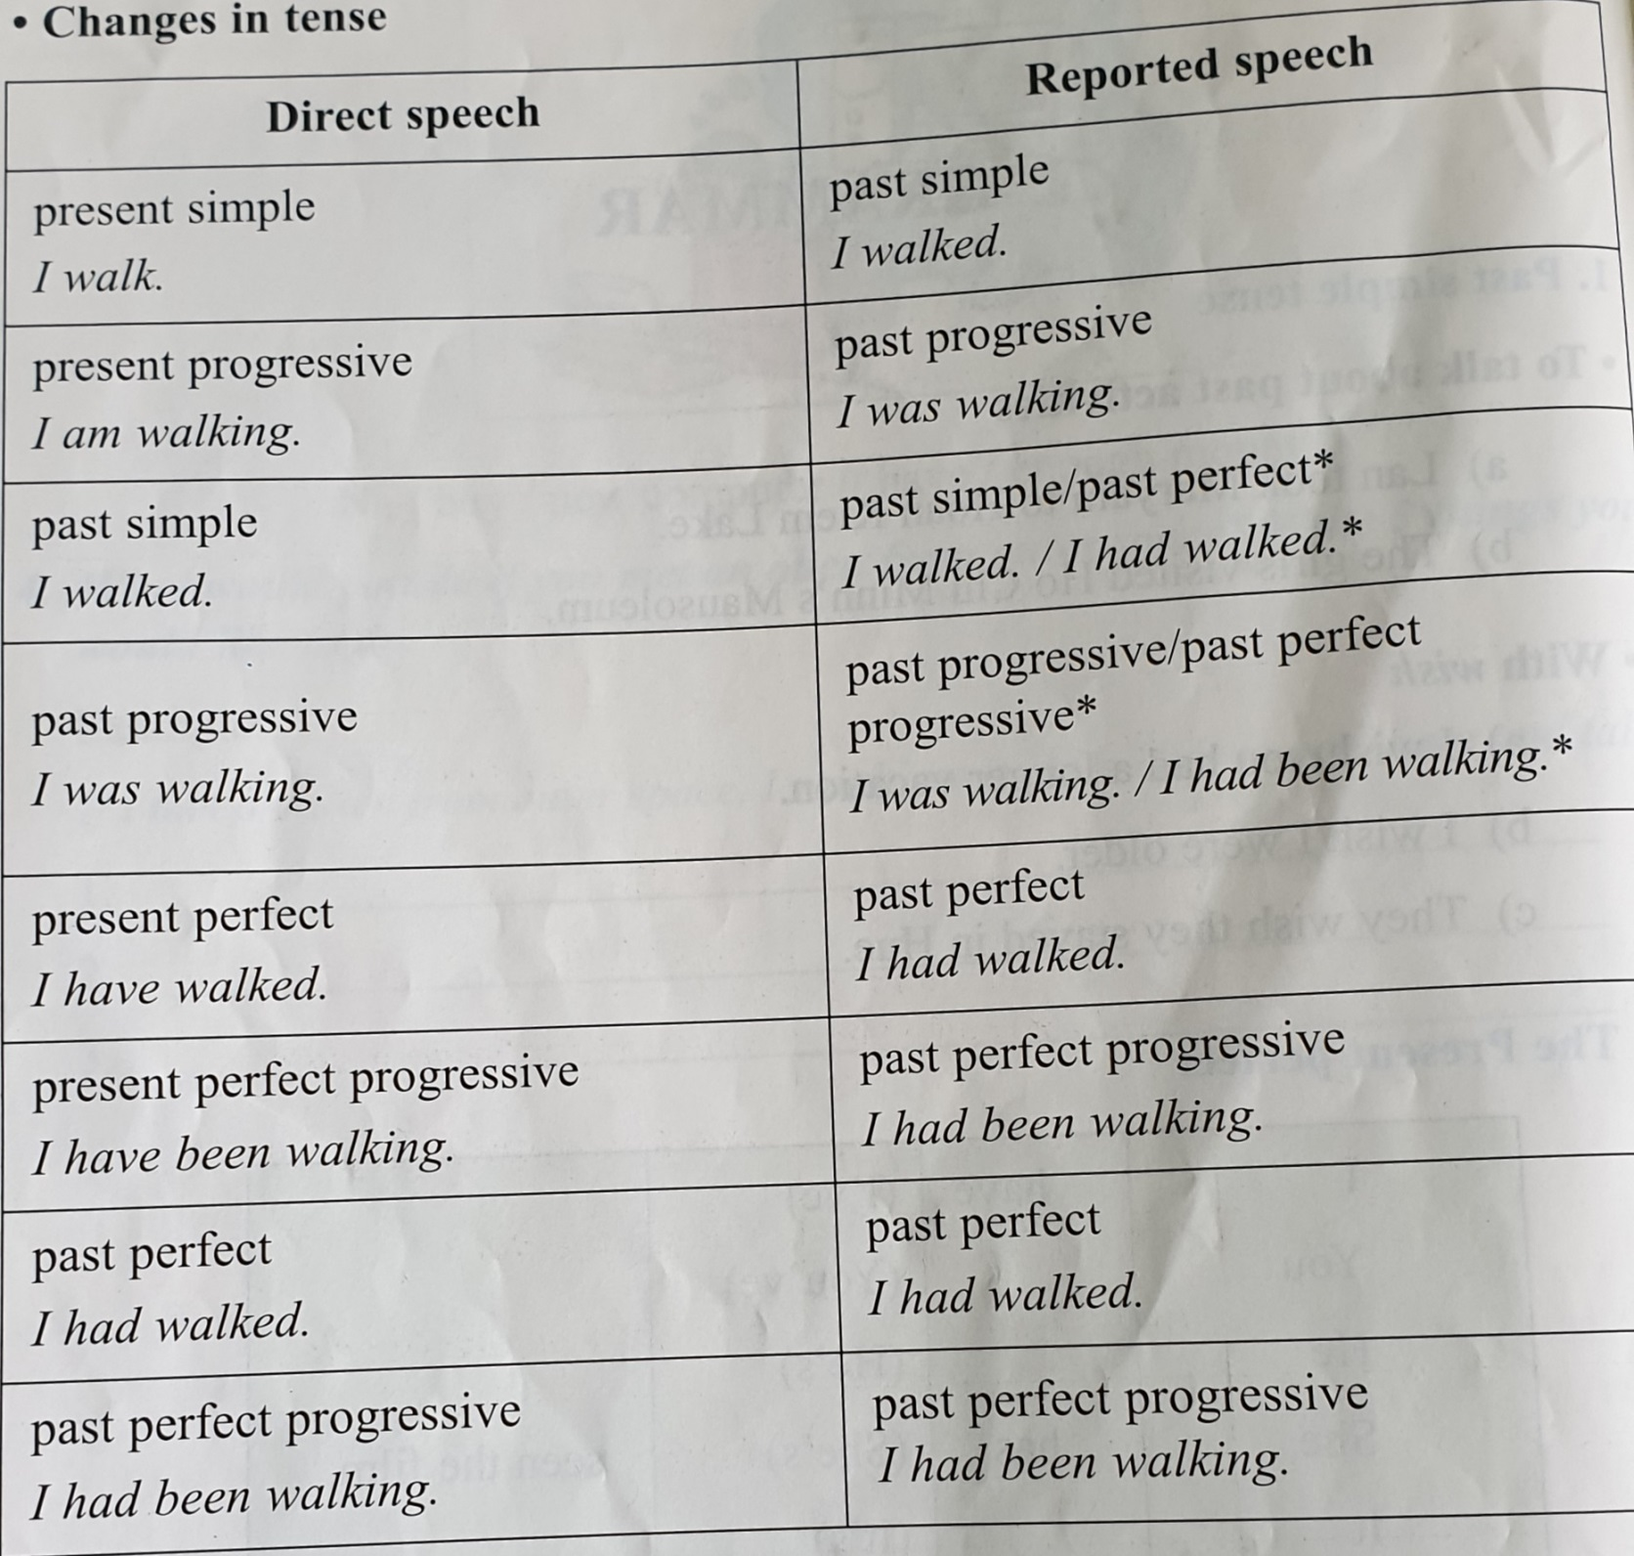

Exercise:
1. “Your house looks great, Long.” – Nga said. → Nga _________________________________
2. “I’m hungry now.” – said the boy. → The boy ______________________________________
3. “Where do you study, children?” – said the man. → The man _________________________
4. “What are you doing now?” she said to me. → She ___________________________________
5. “Do you speak English well, Mai?” – the interviewer said. → The interviewer ____________ ___________________________________________________
6. Are these your new shoes, John?” – said Alice. → Alice ______________________________
IV. Tag questions (Câu hỏi đuôi)
Tag question là loại câu hỏi gồm có 2 phần: phần lời nói (Statement) và phần câu hỏi đuôi (tag question).
- Nếu động từ ở phần lời nói ở thể khẳng định thì động từ ở phần đuôi phải ở thể phủ định và ngược lại:
Eg: Ba is tall, isn’t he? She doesn’t love you, does she?
- Nếu phần đuôi ở thể phủ định thì luôn ở dạng rút gọn: isn’t/ aren’t/ doesn’t/ don’t/ didn’t/ can’t/ …..
Eg: Long can help us, can’t he?
- Chủ ngữ ở phần đuôi luôn là đại từ nhân xưng (I/ he/ she/ it/ we/ you/ they): Hoa broke the dish, didn’t she?
Các trường hợp đặc biệt:
1. I am…., aren’t I? 2. Let’s go, shall we?
3. Câu yêu cầu, cầu khiến: Open the door, will you? –Don’t leave me, will you?
4. Chủ ngữ là: Something/ Nothing/ Everything…, phần đuôi sẽ là: it
5. Chủ ngữ là: Someone/ No one/ Every one…, phần đuôi sẽ là: they
Eg: No one knows him, do they?
6. Phần Statement có các từ: rarely, seldom, hardly, never = not, thì phần đuôi sẽ ở thể khẳng định
Complete the following tag questions:
1. Her father is a doctor, ______________?
2. His sister has a car, ___________________?
3. Bao isn’t nice to you, ______________?
4. I’m your best friend, _______________?
5. Let me go, ____________________?
6. Let’s help those poor people, _________________?
7. Nobody loves you, ________________________?
8. You and I should help her, ____________________?
9. Long has to do the test again, _________________?
10. Phong and Lan have passed the exam, ________________?
11. Don’t make noise, _____________________?
12. The children are studying in the room, __________________?
13. Hoa cut herself badly, _____________________?
14. You don’t love me, ________________?
15. Trung didn’t come, ________________?
16. Trinh hardly goes to school by bus, __________________?
EXERCISES
Choose the word whose underlined part is pronounced differently from that of the others:
1. A. advertise B. exam C. attend D. aspect
2. A. asked B. listened C. lived D. remembered
3. A. songs B. programs C. tapes D. hobbies
Choose the word whose main stress pattern is not the same as that of the others
1. A. passage B. exam C. hobby D. picture
2. A. examiner B. interesting C. dormitory D. necessary
3. A. complete B. forward C. polite D. request

Multiple Choice
1. Hoa never says she loves you, ___________?
- is she B. isn’t she C. does she D. doesn’t she
2. Did you pass the ____________ test?
- speak B. spoke C. speaking D. spoken
3. Han and I are a nice couple, _____________?
- aren’t they B. aren’t we C. aren’t you D. don’t we
4. We look _____________ to coming back to school to study.
- after B. for C. at D. forward
5. Did you ______ her wedding last week? – Oh, sorry. I was busy.
- complete B. attend C. see D. reach
6. Corona virus has killed a lot of people, _________ we must be very careful.
- and B. but C. so D. because
7. The meeting begins at 8 pm. You must be here _____________ 8!
- after B. at C. before D. near
8. Call me when you ___________ the airport! I’ll pick you up.
A. reach B. arrive C. come D. see
9. Can I get ________________ to the internet here?
A. detail B. fee C. access D. passage
10. What ________________ of the job do you find most interesting?
A. kind B. aspect C. means D. force
Supply the correct form of the words
- For further ________________, please call 18000026! (inform)
- It’s _____________________ to wear a face mask when going out. (need)
- We often go ________________________ on the weekend. (picnic)
- This is a chance for _________________ to own an ancient vase of 1800s. (collect)
- Thank you for an __________________ party! (enjoy)
- _______________________, we wish each other best wishes on New Year’s Day. (Tradition)
- The fashion show attracted hundreds of ______________________. (design)
- My baby sister enjoys watching _____________________ on TV. (advertise)
- She thinks that young people today are becoming _________________ selfish.(increase)
- Have you read the latest __________________ of Tuoi Tre News? (edit)

